**Department of Electrical Engineering and   
Computer Science**

**Faculty Member:** Ms. Neelma Naz  **Dated:** 26/04/2023

**Semester**: 6th **Section:** BEE 12C

**EE-371:** **Linear Control Systems**

Lab 11: PID Controller Implementation for QNET DC

Motor

Lab Instructor: Yasir Rizwan

Group Members

|  |  |  |  |  |
| --- | --- | --- | --- | --- |
| **Name** | **Reg. No** | **Lab Report Marks** | **Viva Marks** | **Total** |
|  |  | **10 Marks** | **5 Marks** | **15 Marks** |
| Danial Ahmad | 331388 |  |  |  |
| Muhammad Umer | 345834 |  |  |  |
| Tariq Umar | 334943 |  |  |  |
|  |  |  |  |  |

**Table of Contents**

2 Model Verification 3

2.1 Objectives 3

2.2 Introduction 3

2.3 Software 3

3 Lab Procedure 4

3.1 Exercise 1 4

3.2 Exercise 2 4

3.3 Exercise 3 5

3.4 Exercise 4 6

3.5 Exercise 5 7

3.6 Exercise 6 7

3.7 Exercise 7 8

4 Conclusion 9

# Model Verification

## Objectives

The objectives of this lab are:

* Design and implementation of controllers for speed control of DC motor
* Design and implementation of controllers for position control of DC motor

## Introduction

The PID controller is a widely used controller, accounting for about 80% of dynamic controllers for low-order systems. Its design involves determining the values of Kp, Ki, and Kd to ensure the controller is stable and exhibits certain performance characteristics for the entire system. While the proportional part of the controller is essential, the integral and derivative parts are optional. Typically, the design process begins with a proportional controller, which is the same one designed in a previous lab on root locus. However, it may not always be possible to achieve the desired transient behavior using only a simple proportional controller, as previously observed.

## Software

MATLAB is a high-level programming language and numerical computing environment. Developed by MathWorks, it provides an interactive environment for numerical computation, visualization, and programming. MATLAB is widely used in various fields, including engineering, science, and finance, due to its capabilities for matrix and vector operations, implementation of algorithms, and creation of graphical representations of data.

# Lab Procedure

## Exercise 1

Using the techniques learnt in lab 10 and the model of QNET DC motor found in lab 3, design a simple proportional controller for the speed control of the DC motor. The controller should meet the following specifications:

* %OS
* Settling time is less than 0.5 second

num = 0.0334;

den = [1.566e-5, 1.11556e-3];

plant = tf(num, den);

Kp = 0.038305;

controller = zpk([], [], Kp); % proportional controller

sys = feedback(series(plant, controller), 1);

display(sys)

stepinfo(sys)

Output

sys =

   81.698

  ---------

  (s+152.9)

Continuous-time zero/pole/gain model.

         RiseTime: 0.0144

    TransientTime: 0.0256

     SettlingTime: 0.0256

      SettlingMin: 0.4832

      SettlingMax: 0.5338

        Overshoot: 0

       Undershoot: 0

             Peak: 0.5338

         PeakTime: 0.0479

## Exercise 2

Using the techniques learnt in previous labs implement the proportional controller on the actual plant (i.e., the QNET DC Motor). Using data acquisition, acquire the response of the control system to a step input and see whether the design specifications have been met or not. Load the motor by applying slight friction with your hands. Observe if it maintains the speed or not? How does this differ from open loop control? Comment on your observations in your lab report.

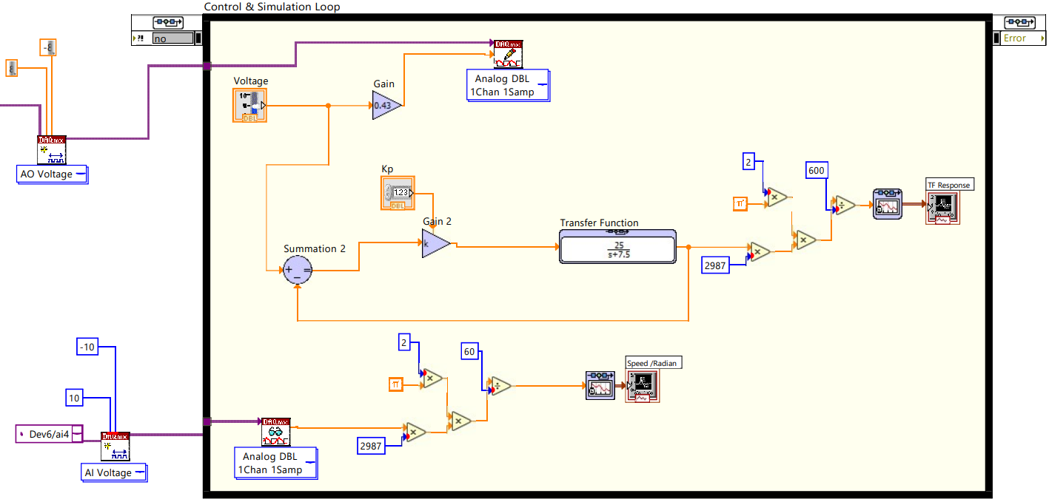

## Exercise 3

Design a PI controller for the speed control of the DC motor. The controller should meet the following specifications:

* %OS
* Settling time is less than 1 seconds
* Zero steady state error for step input

num = 0.0334;

den = [1.566e-5, 1.11556e-3];

plant = tf(num, den);

Kp = 0.01715;

Ki = 1.2221;

ctrl_p = zpk([], [], Kp); % proportional part of controller

ctrl_i = zpk([], 0, Ki); % integral part of controller

ctrl = parallel(ctrl_p, ctrl_i); % controller TF

sys_cl = feedback(series(ctrl, plant), 1); % closed loop sys

stepinfo(sys_cl)

err = abs(1 - dcgain(sys_cl));

step(sys_cl)

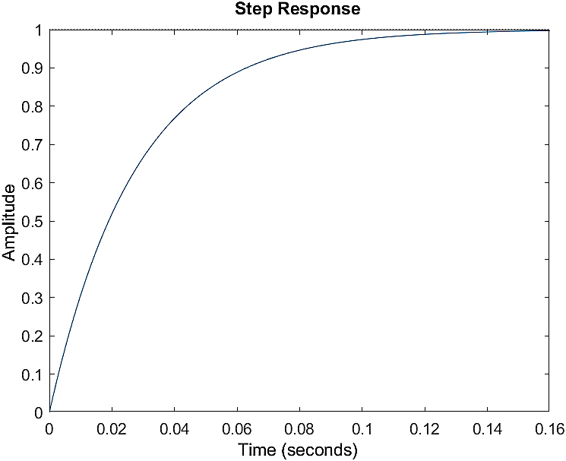

         RiseTime: 0.0600

    TransientTime: 0.1069

     SettlingTime: 0.1069

      SettlingMin: 0.9044

      SettlingMax: 0.9993

        Overshoot: 0

       Undershoot: 0

             Peak: 0.9993

         PeakTime: 0.2000

## Exercise 4

Using the techniques learnt in previous labs implement the proportional controller on the actual plant (i.e., the QNET DC Motor). Using data acquisition, acquire the response of the control system to a step input and see whether the design specifications have been met or not. Load the motor by applying slight friction with your hands. Observe if it maintains the speed or not? How does this differ from open loop control? Comment on your observations in your lab report.

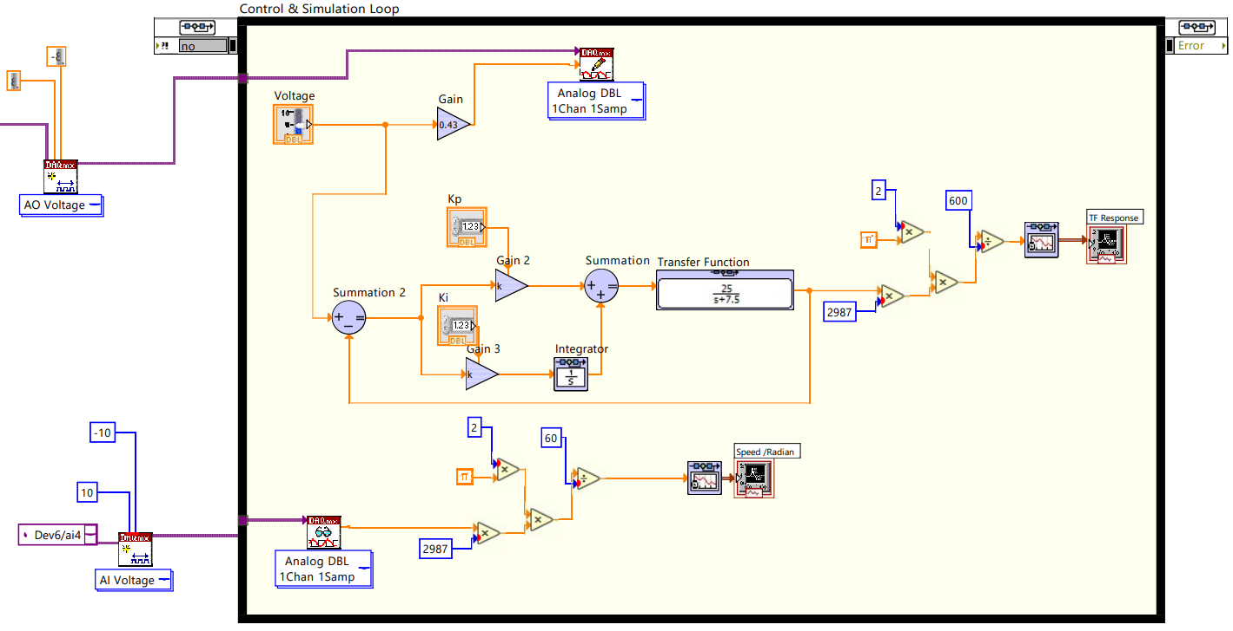

## Exercise 5

Design a simple proportional controller for the position control of the DC motor, such that the closed loop systems is critically damped. Implement this controller on the QNET DC Motor. Using data acquisition, acquire the response of the control system to a step input and see whether the design specifications have been met or not. Load the motor by applying slight friction with your hands. Observe if it gets to the desired position or not? How does this differ from open loop control? Comment on your observations in your lab report.

num = 0.0334;

den = [1.566e-5, 1.11556e-3, 0];

plant = tf(num, den);

Kp = 0.5;

controller = zpk([], [], Kp); % proportional controller

sys = feedback(series(plant, controller), 1);

display(sys)

stepinfo(sys)

Output

sys =

        1066.4

  ------------------

  (s+21.4) (s+49.84)

Continuous-time zero/pole/gain model.

         RiseTime: 0.1168

    TransientTime: 0.2090

     SettlingTime: 0.2090

      SettlingMin: 0.9032

      SettlingMax: 1.0000

        Overshoot: 0

       Undershoot: 0

             Peak: 1.0000

         PeakTime: 0.4971

The motor was able to reach the desired position, implying that the closed loop system with the controller allows for the plant model to be adaptive to the environment, whereas in open loop control, the motor was unable to reach the desired position upon application of friction.

## Exercise 6

Design a PD controller for the position control of the DC motor, to meet the following specifications.

* %OS
* Settling time is less than 0.5 seconds

num = 0.0334;

den = [1.566e-5, 1.11556e-3, 0];

plant = tf(num, den);

Kd = 0.05;

Kp = 0.5;

ctrl_p = zpk([], [], Kp); % proportional part of controller

ctrl_d = zpk(0, [], Kd); % derivate part of controller

ctrl = parallel(ctrl_p, ctrl_d); % controller TF

sys_cl = feedback(series(ctrl, plant), 1); % closed loop sys

stepinfo(sys_cl)

Output

sys_cl =

     106.64 (s+10)

  -------------------

  (s+6.212) (s+171.7)

Continuous-time zero/pole/gain model.

         RiseTime: 0.2193

    TransientTime: 0.4794

     SettlingTime: 0.4794

      SettlingMin: 0.9001

      SettlingMax: 0.9980

        Overshoot: 0

       Undershoot: 0

             Peak: 0.9980

         PeakTime: 0.8472

## Exercise 7

Note that in the transfer function of motor position vs voltage there is a pole at the origin. Therefore, the system type is 1. Consequently, the closed loop system will have zero steady state error for a step input. If the requirement is to have zero steady state error for step input, then we do not need a PI controller. If the input is a ramp, then there will be a non-zero steady state error. In that case we may have a PI compensator to increase the steady state error. Design a PID controller to meet the following specifications:

* %OS
* Settling time is less than 0.5 seconds
* Zero steady state error for ramp input

num = 0.0334;

den = [1.566e-5, 1.11556e-3, 0];

plant = tf(num, den);

Kd = 0.029039;

Kp = 1.1021;

Ki = 6.3464;

ctrl_p = zpk([], [], Kp); % proportional part of controller

ctrl_i = zpk([], 0, Ki); % integral part of controller

ctrl_d = zpk(0, [], Kd); % derivative part of controller

ctrl = parallel(parallel(ctrl_p, ctrl_i), ctrl_d); % controller TF

sys_cl = feedback(series(ctrl, plant), 1); % closed loop sys

err = abs(1 - dcgain(sys_cl))

Output

sys_cl =

     61.935 (s+30.87) (s+7.079)

  --------------------------------

  (s+113.5) (s^2 + 19.66s + 119.2)

Continuous-time zero/pole/gain model.

         RiseTime: 0.0585

    TransientTime: 0.4293

     SettlingTime: 0.4293

      SettlingMin: 0.9026

      SettlingMax: 1.0983

        Overshoot: 9.8325

       Undershoot: 0

             Peak: 1.0983

         PeakTime: 0.1826

err =

   6.6613e-16

# Conclusion

In conclusion, the proportional-integral-derivative (PID) controller is a widely used controller that is essential in ensuring stable and optimal performance of low-order systems. The design process involves determining the gains of Kp, Ki, and Kd to guarantee stability and specific performance characteristics of the entire system. While the proportional part of the controller is a critical component, the integral and derivative parts are optional. However, it is not always possible to achieve the desired transient behavior using only a proportional controller. Therefore, it is important to consider incorporating the integral and derivative parts in the design process when necessary. Overall, the PID controller is a powerful tool for controlling dynamic systems, and its effective application can lead to improved system performance and stability.